T-1450-15

FEDERAL COURT OF CANADA

BETWEEN:

Radu Hociung
Plaintiff

and

Minister of Public Safety and Emergency Preparedness
Defendant

RESPONSE TO MOTION

Radu Hociung
246 Southwood Drive
Kitchener, ON
N2J 3M1
Tel: (519) 883-8454
Fax: (226) 336-8327
email: radu.cbsa@ohmi.org

TO:

The Registrar
Federal Court of Canada
180 Queen Street West
Suite 200
Toronto, Ontario
M5V 3L6

AND TO:
Eric Peterson
Department of Justice
Ontario Regional Office
The Exchange Tower
130 King St. West
Suite 3400, Box 35
Toronto, Ontario
M5X 1K6
Tel: (416) 952-6334
Fax: (416) 973-5004
T-1450-15

FEDERAL COURT OF CANADA

BETWEEN:

Radu Hociung
Plaintiff

and

Minister of Public Safety and Emergency Preparedness
Defendant

INDEX
Tab | Document | Page No
1 | Notice of Motion | 1-2
2 | Respondent's Submissions | 3-7
3 | Minister of Finance Affidavit
4 | Currency Act, R.S.C, 1985, c. C-52, section 7, 11

INDEX

INDEX

Tab | Document | Page No
1 | Notice of Motion | 1-2
2 | Respondent's Submissions | 3-7
3 | Minister of Finance Affidavit
4 | Currency Act, R.S.C, 1985, c. C-52, section 7, 11

TAB 1

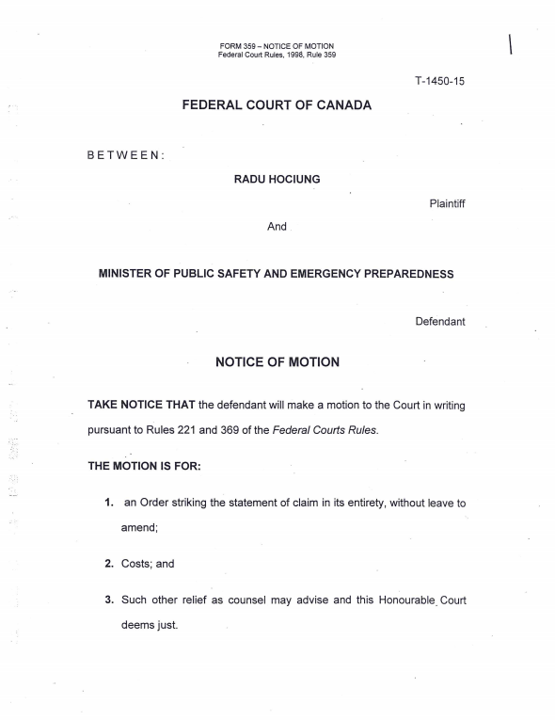
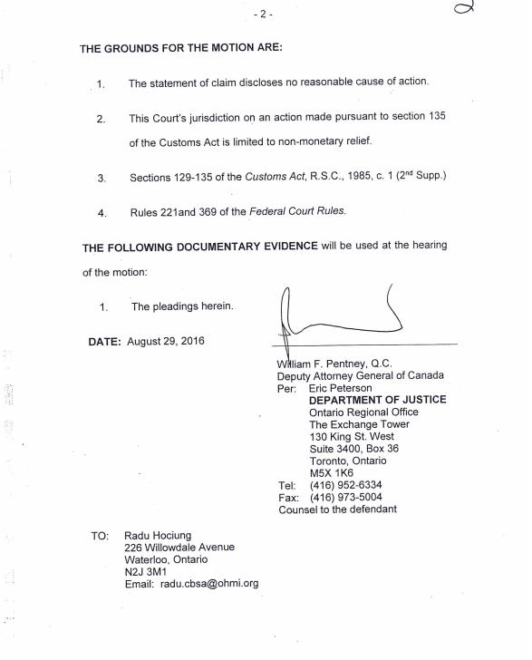

TAB 2

Submissions
- [reply to Memo of Fact and Law para 3] The Defendant's motion states simply that “collector coins are considered goods”, but provides no statutory reference to this effect. This opinion is not sufficient to defend against claims based on US Title 31 references in the Statement of Claim, that clearly prove that the coins are currency and legal-tender.

- [29] The Defendant's motion relies on section 8 of the Currency Act, which does not apply to US Treasury coins. The Currency Act applies only to the currency of Canada.

- Even if Currency Act s.8 did apply to coins issued by the US Treasury, it expressly states that coins of denominations $1 and $50 (such as the coins in question in this action), may be used for payments. Also, section 8 does not define currency, but rather states how currency, defined in section 7, may be used for payments. The Defendant claims that s.8 states the opposite of what it does.

- The Defendant's motion also relies on a definition of “currency” from the Oxford Dictionary. The Oxford dictionary lists at least 4 distinct definitions for “currency” as it relates to money. As “currency” is more precisely defined in existing statutes (Currency Act, Excise Tax Act, Proceeds of Crime (Money Laundering) and Terrorist Financing Act and US Title 31), the use of an imprecise dictionary definition is not appropriate.

- [6] Section 106 of the Customs Act only applies to officers in the “performance of his duties under the Customs Act of any other Acts of Parliament”. In this case, as the Customs Act does not apply to currency, the officer had no duty to perform pursuant the Customs Act or any other Act of Parliament, other than to verify that the prescribed amount in the PCMLTFA was not exceeded. The officer was committing fraud, misrepresenting the Customs Act to support an unlawful seizure. As such, the limitations afforded by section 106 of the Customs Act do not apply.

- Section 135 of the Customs Act sets a time limit on appeals, sets which Court actions are to be brought in, who the defendant is, and the form of the appeal. It does not limit the Court with respect to the relief it may decide on, nor does it limit the action from seeking relief based on other Acts of Parliament.

- Furthermore, as the currency is not subject to any provisions of the Customs Act, the Minister does not have authority to decide to seize currency pursuant the Customs Act, or any other authority with respect to imported currency, and is not afforded limitations specified in the Act.

- [18] There is no Federal Court Rule requiring a claim for damages be brought separately.

- [20] While the Statement of Claim is supported with precise statute references, the Defendant's Statement of Defense and present Motion use unsupported opinion, Oxford dictionary definitions, and misinterpreted and inapplicable statute (Currency Act section 8). Based on these facts, the claim has far more than a reasonable prospect of success.

- Futher to [24], U.S. Treasury coins match the “coins or bank notes of countries other than Canada” definition of “cash” in the PCMLTFR, and thus are subject to the PCMLTFA, and not the Customs Act.

- [19] While the central issue in dispute is whether U.S. Treasury currency is goods, there are two further issues:
  - Whether the Customs Act applies to currency, and
  - Whether the CBSA has undermined the purpose of the Proceeds of Crime (Money Laundering) and Terrorist Financing Act by not enforcing its reporting requirements with respect to precious metal coinage imported and exported from Canada since CBSA's inception. There is presently about $1.8 billion of such precious metal currency that the FINTRAC is interested in, but the CBSA conceals by treating this currency as “goods”, and the Minister appears committed, based on the arguments made in the Statement of Defence,
and this Motion, that the practice of aiding criminal and terrorist financing continue.

- [27] As to the value of gold and silver coins; In Canada, as well as the U.S., the value of currency is set by decree (Currency Act sec 7, similarly in the U.S. ), not by collector desirability, nor by the metal it is made of, nor by circulation status.

- Further to [28]. The U.S. Code Title 31 (Money and Finance) does not make any mention of circulation intent, rather, lists the gold and silver coins on the same list of denominations as the more popular coins, and further states they are all current legal-tender. The defendant is not only unfamiliar with the content of U.S. Code Title 31, but is making wrong assumptions about the intent to circulate of U.S. Coinage.

- The Statement of Claim clearly claims that the coins are financial instruments as defined by the Excise Tax Act (claim 1.e). The Excise Tax Act states that “foreign gold coin” is not subject to sale or import tax and duty (section 51, and Schedule III Part XI, para 3). It states the same about “Coin of any metal, of authorized weight and design, issued for use as currency under the authority of the government of any country” (Schedule III Part XI, para 4).

- The Plaintiff intends file a motion for leave to amend the Statement of Claim, to clarify which Act each of the reliefs sought is based on, and to further make additional claims based on information discovered by the Plaintiff after the Statement of Claim was filed.

- The Minister of Finance's affidavit referred to in claim 4.b of the Statement of Claim, and provided as supporting documentation to the CBSA Recourse Directorate prior to the Minister's Decision, is attached as Appendix A.

- As a result of the foregoing, there is every prospect that the claim will succeed.

- Presently the Defendant is in default of Federal Court Rule 99(4), having been served a written examination request on July 21st, 2016, and having not served a written response affidavit within 30 days, as required by Rule 99(3). Such, the intent of the Defendant is to derail the legal process by seeking a dismissal before additional discovery. On this basis, this Motion should be denied.

TAB 3
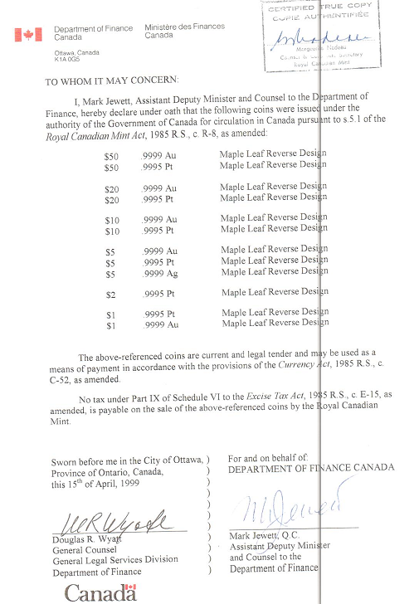

TAB 4

Currency Act

R.S.C., 1985, c. C-52

Current Coins

7. (1) A coin is current for the amount of its denomination in the currency of Canada if it was issued under the authority of
(a) the Royal Canadian Mint Act; or
(b) the Crown in any province of Canada before it became part of Canada and if the coin was, immediately before October 15, 1952, current and legal tender in Canada.
(2) No coin that is bent, mutilated or defaced, or that has been reduced in weight otherwise than by abrasion through ordinary use, shall pass current.

R.S., 1985, c. C-52, s. 7; 1999, c. 4, s. 11.

Melting Coins

11. (1) No person shall, except in accordance with a licence granted by the Minister, melt down, break up or use otherwise than as currency any coin that is current and legal tender in Canada.
(2) Every person who contravenes subsection (1) or any condition attached to a licence referred to in that subsection is liable on summary conviction to a fine not exceeding two hundred and fifty dollars or to imprisonment for a term not exceeding twelve months or to both, and, in addition to any fine or imprisonment imposed, the court may order that the articles by means of or in relation to which the offence was committed be forfeited to Her Majesty.
R.S., c. C-39, s. 10.

